Tableau – Appspace
Digital Signage Integration
Solution Architecture Document (SAD)
Document Type | Solution Architecture Document
Architecture Domain | Integration / BI & Digital Signage
Audience | Enterprise / Solution Architects, Security Review Board
Owner | Data & BI Support Team
Status | Draft – For Architecture Review
Version | 1.0
Last Updated | 21 July 2026

Table of Contents
1. Document Purpose & Audience
2. Architecture Overview
3. Logical Architecture
4. Component Description
5. Integration & Authentication Architecture
6. Data Flow Architecture
7. Deployment & Network Topology
8. Security Architecture
9. Non-Functional Requirements
10. Technology Stack Summary
11. Assumptions, Constraints & Dependencies
12. Risks & Mitigations
13. Architecture Decision Log
14. References

1. Document Purpose & Audience
This Solution Architecture Document (SAD) defines the technical architecture for integrating Tableau Cloud dashboards with the Appspace digital signage platform. It is intended for solution architects, security reviewers, and infrastructure teams who need to assess, approve, or extend the integration.
This document focuses on architectural structure, integration patterns, security posture, and non-functional characteristics. Step-by-step configuration instructions are maintained separately in the companion Enterprise Solution / Operational Reference Document.

2. Architecture Overview
The solution connects two independent SaaS platforms — Tableau Cloud (analytics/BI) and Appspace (digital signage CMS) — via a trust-based authentication mechanism (Direct Trust / Connected App), without any customer-hosted middleware. Dashboards remain governed and rendered by Tableau; Appspace is responsible only for scheduling, embedding, and distributing the dashboard view to physical display endpoints.

2.1 Architecture Style
- Pattern: SaaS-to-SaaS integration via token-based trust (no on-premises broker required).
- Style: Embedded content delivery — Appspace acts as a display/consumption layer, not a data processing layer.
- Coupling: Loosely coupled; Tableau and Appspace can be upgraded or reconfigured independently as long as the trust contract (Connected App) remains valid.

3. Logical Architecture
The logical view below groups the solution into five layers: Data & Analytics, Integration & Security, Presentation/CMS, Distribution, and Consumption.
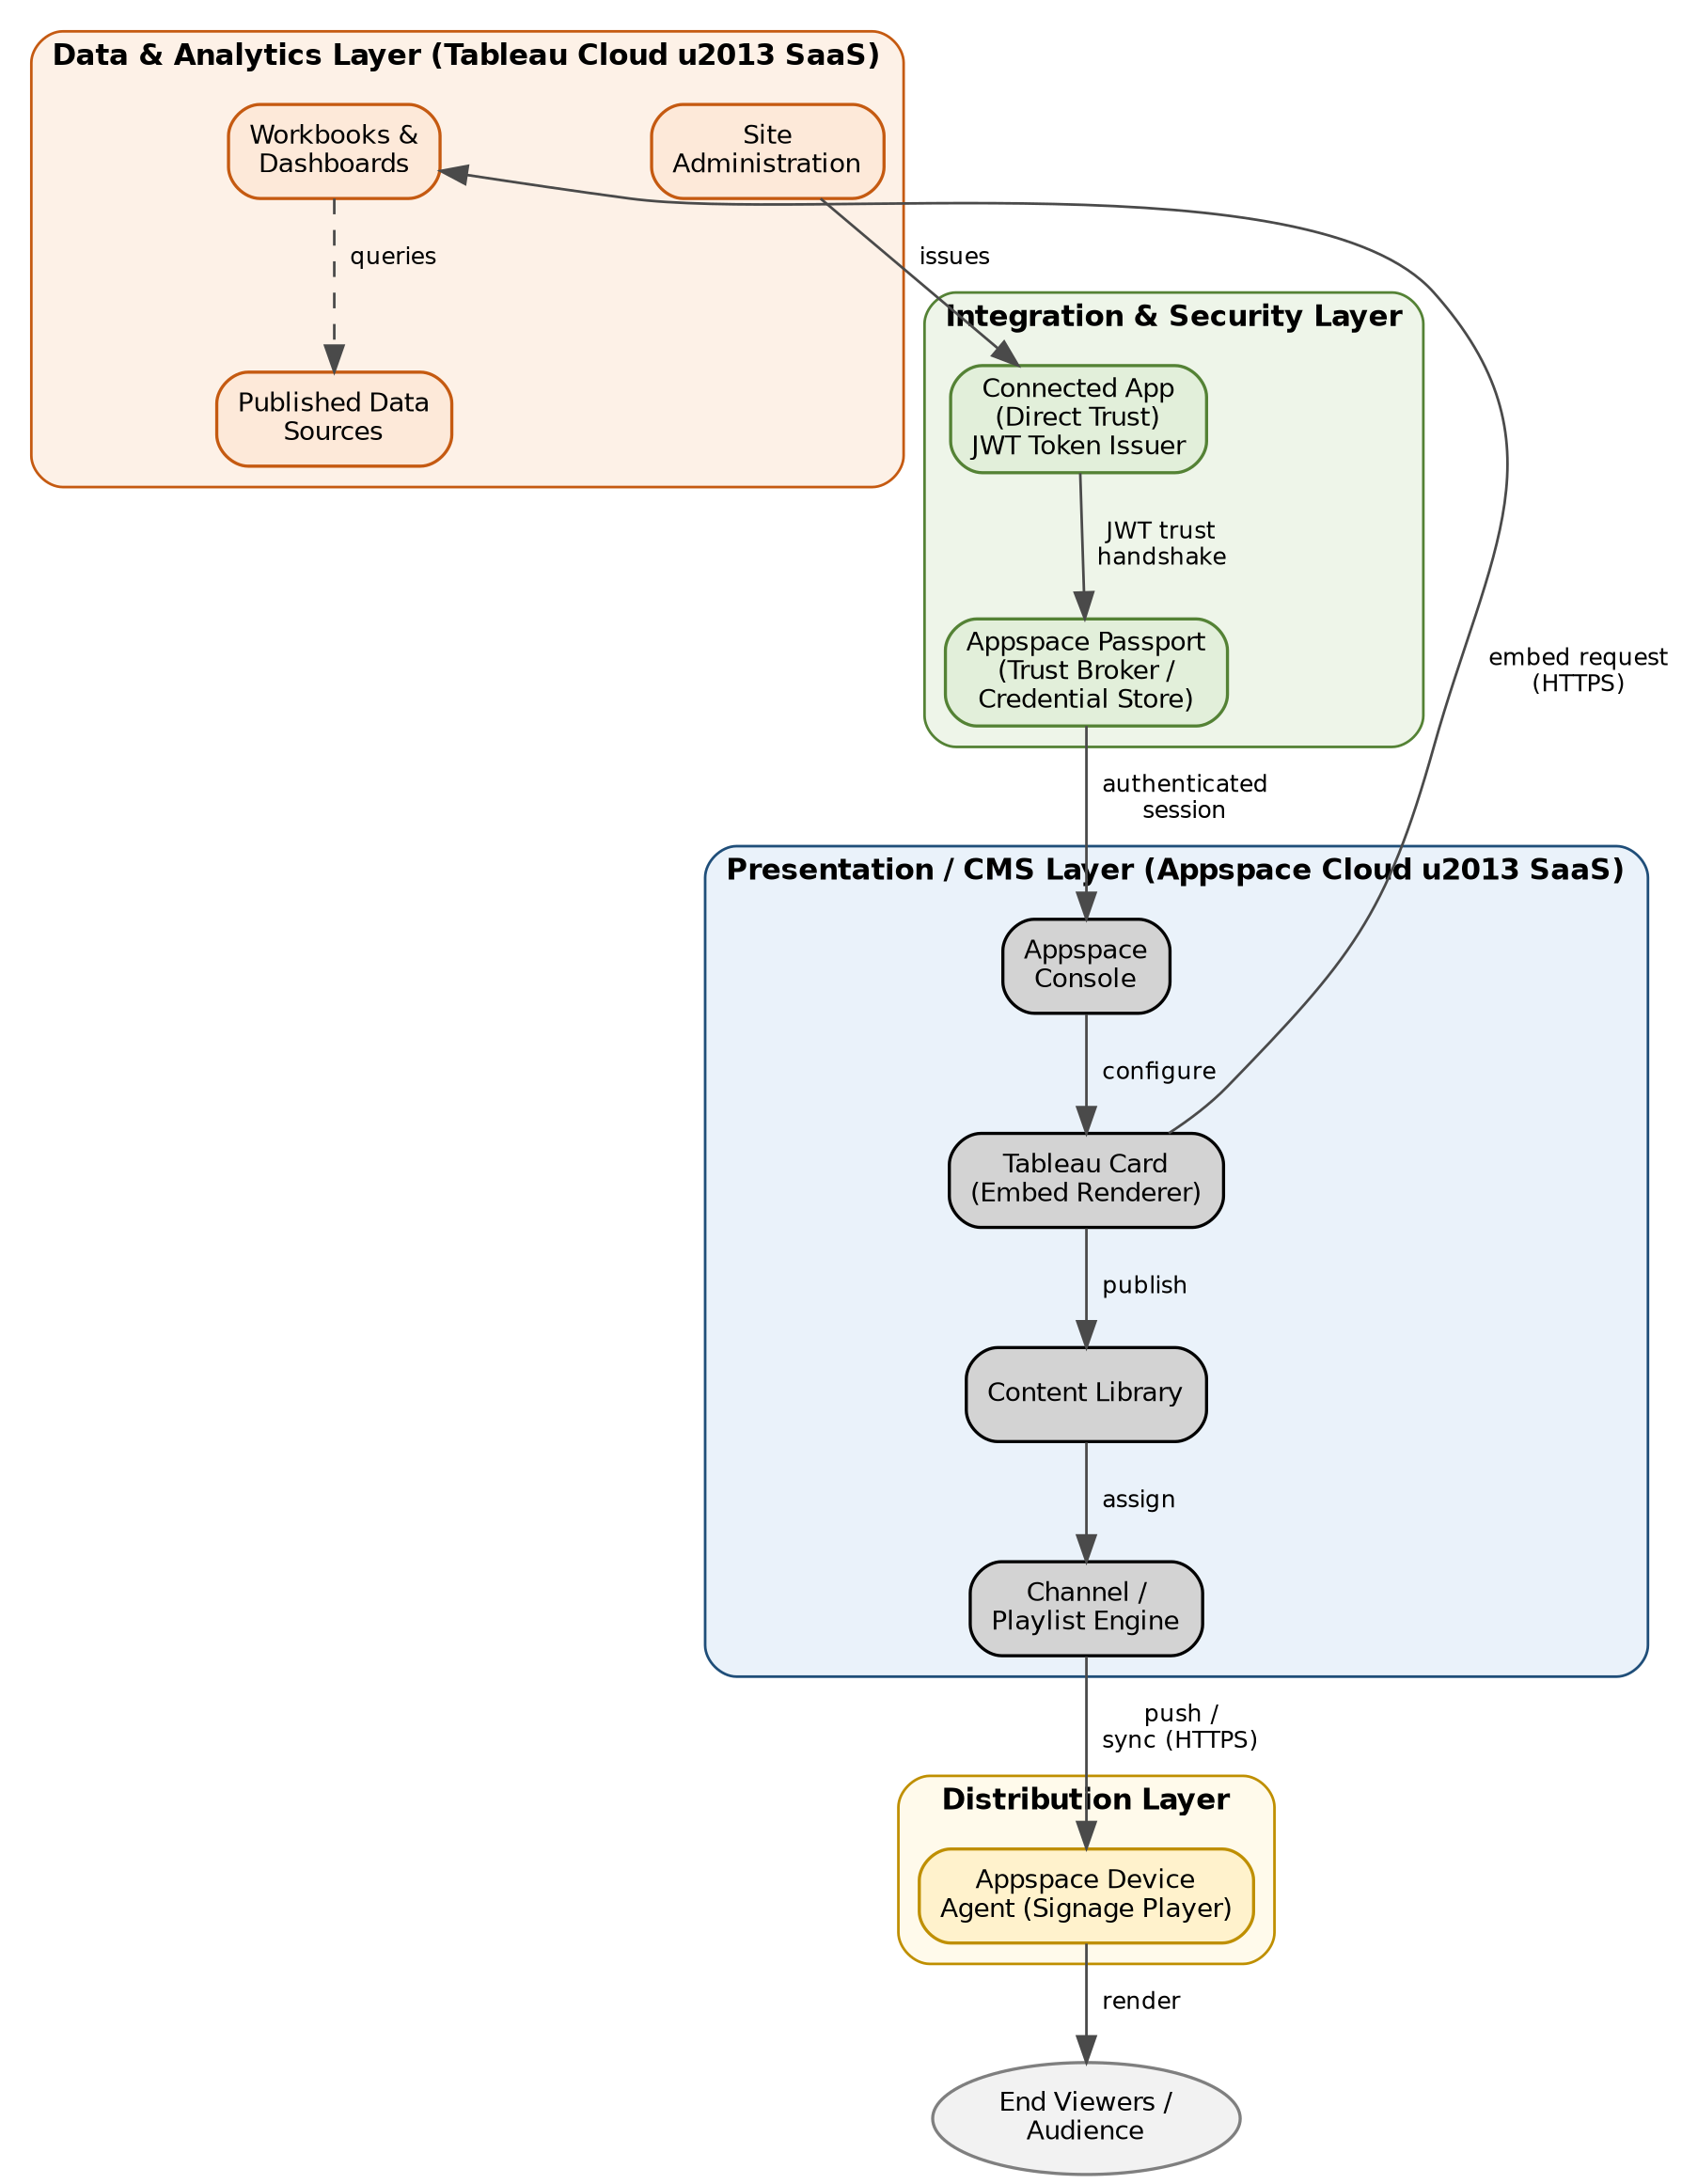
Figure 1: Logical architecture – layered view

4. Component Description
Component | Description | Hosting
Published Data Sources | Underlying datasets powering Tableau workbooks | Tableau Cloud (SaaS)
Workbooks & Dashboards | Governed dashboard content selected for signage display | Tableau Cloud (SaaS)
Connected App | Issues signed JWT trust tokens for embedded, authenticated access (Direct Trust) | Tableau Cloud (SaaS)
Appspace Passport | Stores Connected App credentials; brokers trust handshake with Tableau | Appspace Cloud (SaaS)
Appspace Console | Administrative UI for card creation, scheduling, and channel management | Appspace Cloud (SaaS)
Tableau Card | Content object that embeds the dashboard via authenticated session or public URL | Appspace Cloud (SaaS)
Content Library / Channel Engine | Manages content versioning, scheduling, and channel/playlist assignment | Appspace Cloud (SaaS)
Device Agent | Signage player software on the physical display; pulls and renders assigned channel content | Edge – Corporate Network

5. Integration & Authentication Architecture
Authentication uses Tableau's Direct Trust model via a Connected App. This avoids storing end-user credentials in Appspace and avoids exposing the Tableau Cloud site to unauthenticated public access. The flow below shows the trust establishment sequence and the ongoing request pattern.
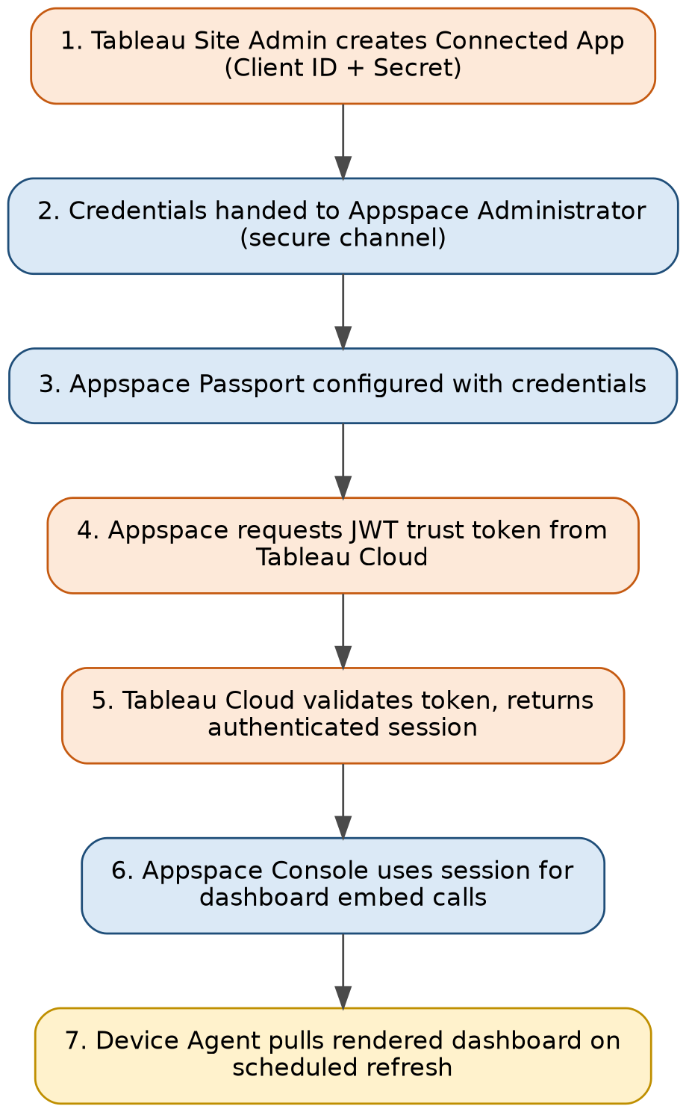
Figure 2: Authentication and trust establishment flow

5.1 Integration Pattern
- Trust type: OAuth-like JWT-based Direct Trust (Tableau Connected App).
- Credential storage: Client ID and Secret stored encrypted within the Appspace Passport configuration — not visible to card authors.
- Token lifecycle: Short-lived JWTs are minted per session request; no long-lived static credentials are passed to end devices.
- Alternative pattern (not recommended for enterprise): Public Dashboard mode, which uses an unauthenticated Tableau Public URL and bypasses the trust layer entirely.

6. Data Flow Architecture
No data is persisted or cached within Appspace beyond transient render output. Each display refresh triggers a new authenticated request back to Tableau Cloud, ensuring dashboard data shown on signage always reflects the live (or last Tableau-scheduled) extract refresh.
- Data at rest: Remains solely within Tableau Cloud's governed data sources; Appspace does not store underlying data.
- Data in transit: All communication (Tableau ↔ Appspace ↔ Device) is encrypted via HTTPS/TLS 1.2+.
- Refresh behaviour: Dashboard refresh cadence is controlled by Tableau extract/live-connection settings, not by Appspace.
- Caching: Appspace may cache rendered output briefly for display performance; no raw data extraction or storage occurs on Appspace infrastructure.

7. Deployment & Network Topology
Both platforms are fully SaaS-hosted; there is no on-premises server component for this integration. The only on-premises footprint is the signage device endpoints and the administrator workstation, both of which communicate outbound over HTTPS.
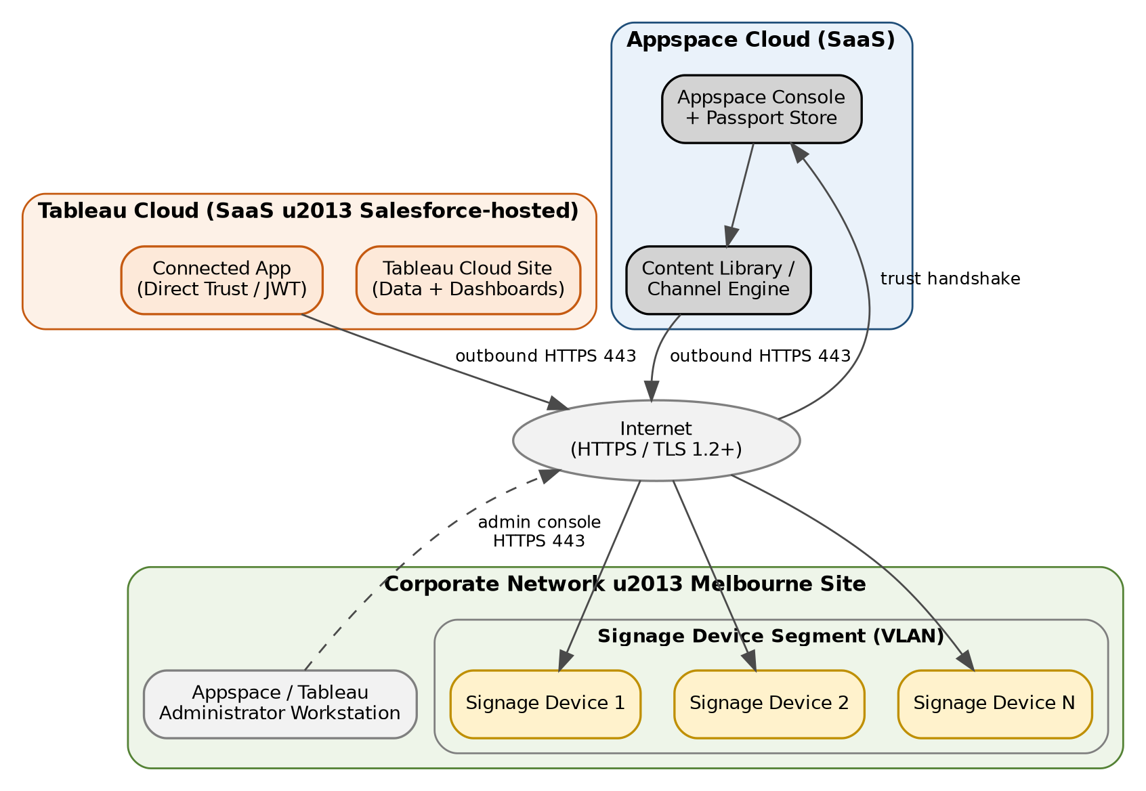
Figure 3: Deployment and network topology

7.1 Network Requirements
- Outbound HTTPS (TCP 443) from the signage device VLAN to Appspace Cloud endpoints — no inbound firewall rules required.
- Outbound HTTPS (TCP 443) from Appspace Cloud to Tableau Cloud for token validation and dashboard embed requests.
- No direct network path required between signage devices and Tableau Cloud — all dashboard content is proxied through Appspace.

8. Security Architecture

8.1 Authentication & Authorization
- Direct Trust (Connected App) removes the need for shared or embedded end-user passwords.
- Dashboard-level permissions remain governed entirely within Tableau Cloud; Appspace cannot expose content beyond what the Connected App's scoped access allows.
- Recommendation: scope the Connected App to the minimum required Tableau project(s) rather than site-wide access.

8.2 Data Protection
- All traffic encrypted in transit (TLS 1.2+); no plaintext credential transmission.
- No sensitive data at rest within Appspace — dashboards are rendered on demand, not stored.

8.3 Credential Management
- Connected App Client ID/Secret should be rotated per organizational key-rotation policy.
- Access to the Appspace Passport configuration should be restricted to Appspace Account Owners only.

8.4 Auditability
- Tableau Cloud audit logs record Connected App token issuance and dashboard access events.
- Appspace activity logs record card creation, publishing, and channel assignment changes.

9. Non-Functional Requirements
Attribute | Consideration
Availability | Dependent on Tableau Cloud and Appspace Cloud SaaS SLAs; no self-hosted single point of failure introduced by this integration.
Scalability | Additional signage devices or dashboards can be added without architectural change — scaling is handled by both SaaS platforms.
Performance | Dashboard render time on signage is bound by Tableau query/extract performance; dashboards should be optimized for a fixed, non-interactive canvas.
Maintainability | Single Passport can be reused across many cards, minimizing configuration drift.
Portability | Loosely coupled SaaS-to-SaaS design; either platform can be replaced independently if the trust contract is re-established.

10. Technology Stack Summary
- Analytics / BI Platform: Tableau Cloud
- Authentication: Tableau Connected App (Direct Trust, JWT)
- Digital Signage CMS: Appspace Cloud (version 8.1+)
- Content Type: Appspace “Tableau Card” (Data card template)
- Transport Security: HTTPS / TLS 1.2+
- Display Endpoints: Appspace-registered signage device agents

11. Assumptions, Constraints & Dependencies

11.1 Assumptions
- Tableau Cloud subscription includes Creator-level access required to configure Connected Apps.
- Appspace tenant is licensed at version 8.1 or later, supporting the Tableau Card type.
- Signage devices already registered and provisioned within Appspace prior to this integration.

11.2 Constraints
- Only Tableau dashboards (not reports) can be embedded — a platform limitation of the Appspace Tableau Card.
- Dashboards are not responsive within the card; layout must be purpose-built for the target display resolution.
- No architectural control over Tableau Cloud or Appspace Cloud infrastructure — both are third-party managed SaaS.

11.3 Dependencies
- Availability and API stability of Tableau Cloud's Connected App / Direct Trust feature.
- Availability of Appspace Cloud's Passport and Tableau Card content type.

12. Risks & Mitigations
Risk | Impact | Mitigation
Connected App token/secret expires or is revoked | Dashboards stop rendering on all signage using that Passport | Scheduled credential review; alerting on authentication failure
Over-broad Connected App scope | Signage could expose more data than intended | Scope Connected App to specific project(s); least-privilege review
Use of Public Dashboard mode for internal data | Unauthenticated public exposure of enterprise data | Enforce Private Dashboard mode as the only approved pattern via governance policy
SaaS outage (Tableau or Appspace) | Signage displays stale or blank dashboard content | Monitor vendor status pages; define fallback content on devices

13. Architecture Decision Log
Decision | Rationale
Use Private Dashboard (Direct Trust) mode as the standard pattern | Preserves Tableau governance and avoids exposing enterprise data via unauthenticated public URLs
No custom middleware / broker service introduced | Both platforms provide native SaaS-to-SaaS trust support, removing the need for a hosted integration layer
Single shared Passport per environment | Simplifies credential management; reduces duplicate trust configurations across cards

14. References
- Appspace Community – Cards: Display Tableau Dashboard: community.appspace.com/cards-134/cards-display-tableau-dashboard-627
- Tableau Help – Configure Connected Apps with Direct Trust (help.tableau.com)
- Appspace Community – Supported Appspace Cards reference article
- Appspace Community – Tableau Card Release Notes
- Companion document: Tableau – Appspace Enterprise Solution Document (operational/configuration reference)

